**EYE POSITION ESTIMATOR**

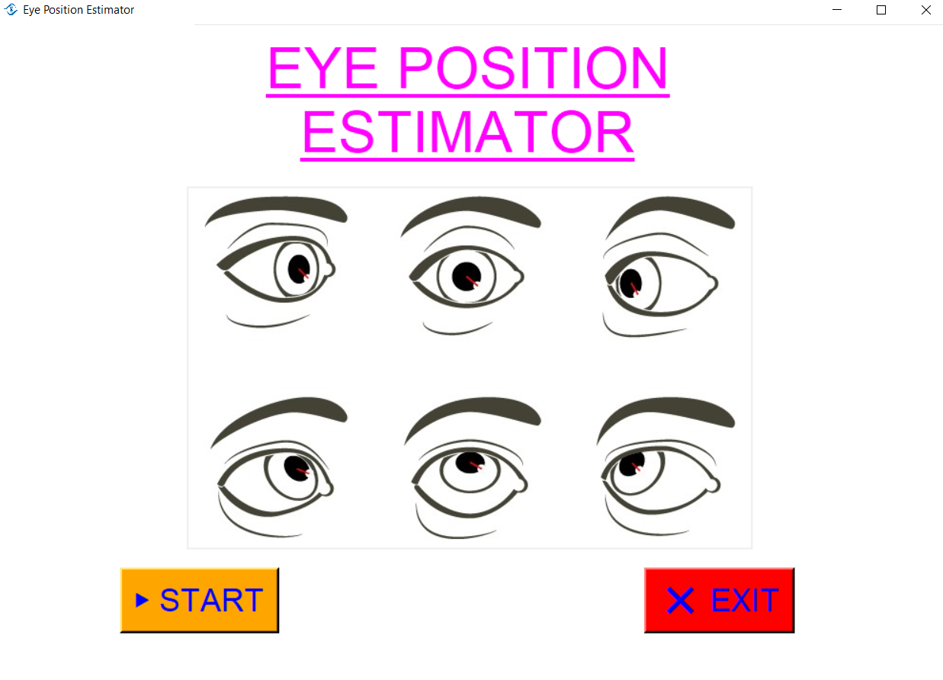

* **PROJECT TITLE :-** EYE POSITION ESTIMATOR
* **GROUP NO. :** 3
* **TEAM MEMBERS :**

1.) AKASH RAMANAND RAJAK (435)

2.) ARUN KUMAR (444)

3.) PALLI HRITAM RAO (482)

* **PROBLEM STATEMENT**

In various medical treatment or eye operation, accurate image scan of both eyes are necessary. Along with that, the eyes image scan should be with better accuracy of both eyes position and also there should not be any eye blinking error.

* **Tools & Technologies**

1.) Python Language

2.) OpenCv

3.) Image Processing & Understanding using Mediapipe library in python

4.) tkinter, for GUI configuration

* **DETAILS OF APPLICATION**

Here in this we have developed a model using python language and its various libraries. The basic idea of this model is to detect the position of eyes in the real time video, analyze the landmarks of the eyes including face and also keep track of eye blinking effect.

The overall model is classified into two section, ones via video and another is working via camera.

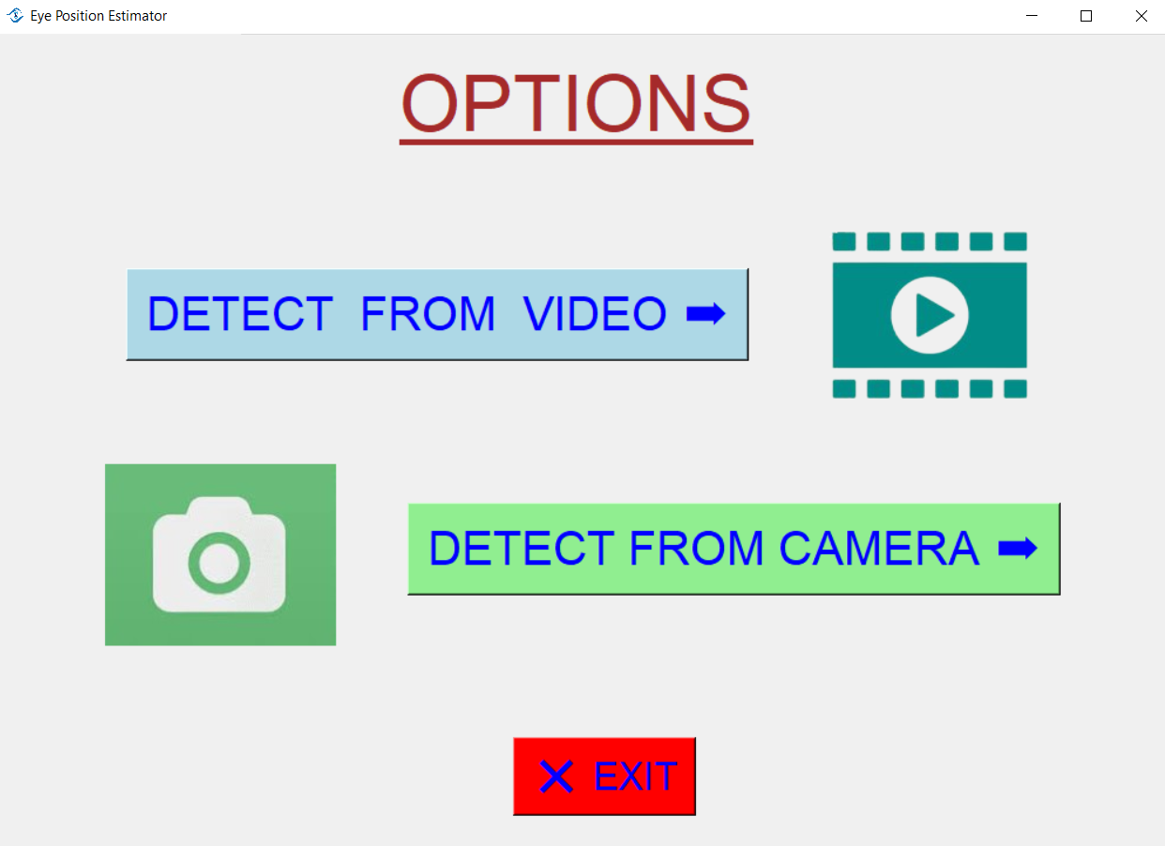

In Video section, first the user needs to select any video file from the local system and, then user will see various option like,

**PREVIEW**(using which user will be able to preview the video selected from the local system),

**LANDMARKS**(allows user to see the landmarks on the face in the video with boundaries),

**DETECT**(using which user will be able to detect the eye position and even keep track of eye blinking)

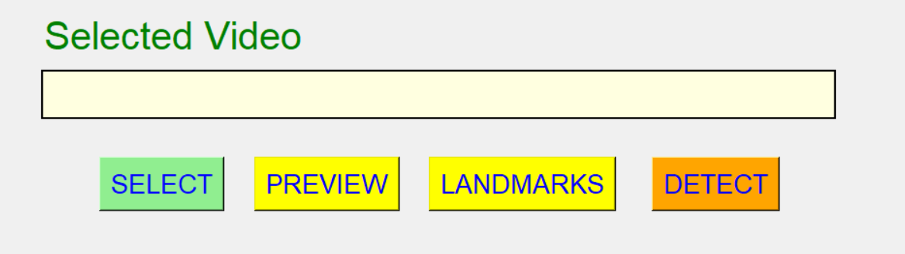

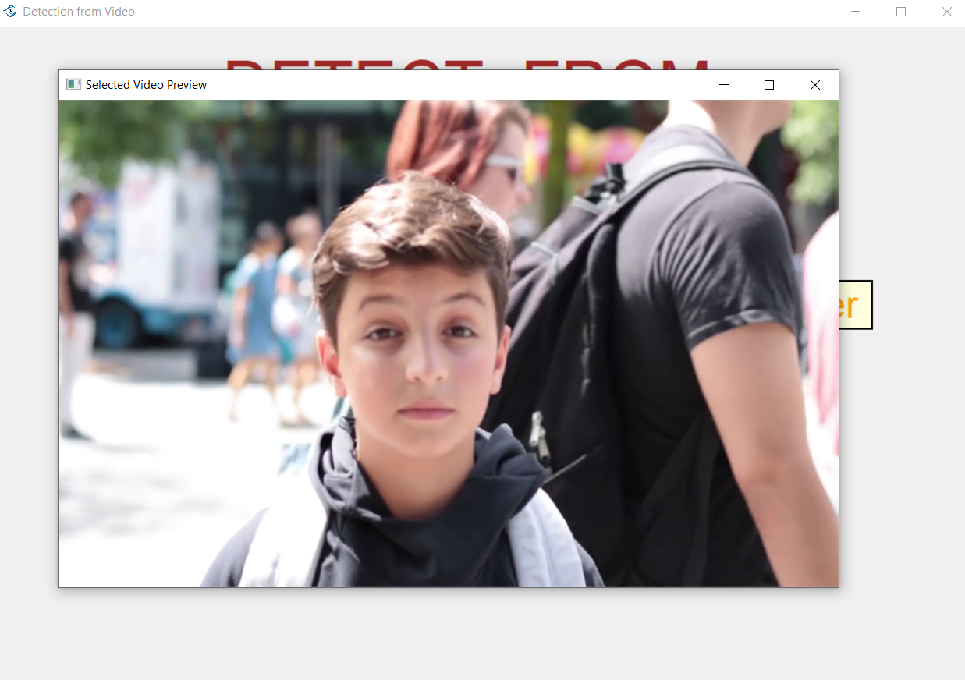

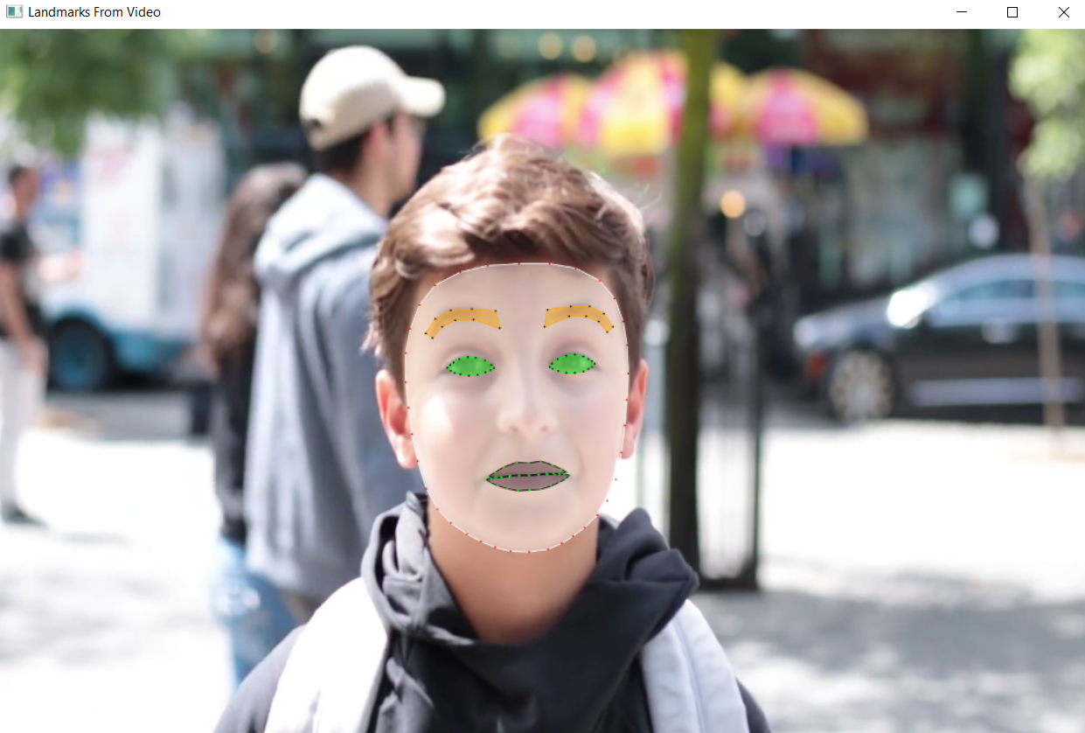

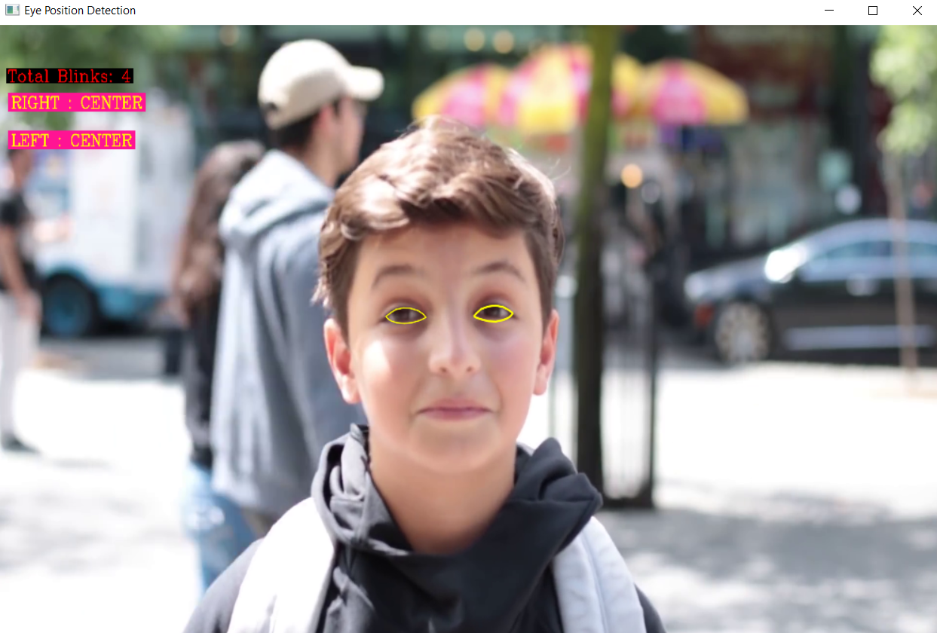

Here while the video is running, user will be able to see the total blink counts, and along with that, it also tells us about the position of the both left and right eye at each frame. And will be able to see the yellow boundary around the person’s eye specifying the eye region.

After we stop the video, a message will be displayed that “Detection Completed” and a button will get created “Graph Analysis”, clicking on which user will be able to see the eye blink vs. time graph, which shows user in which time stamp, the person in the video has blinked his eyes.

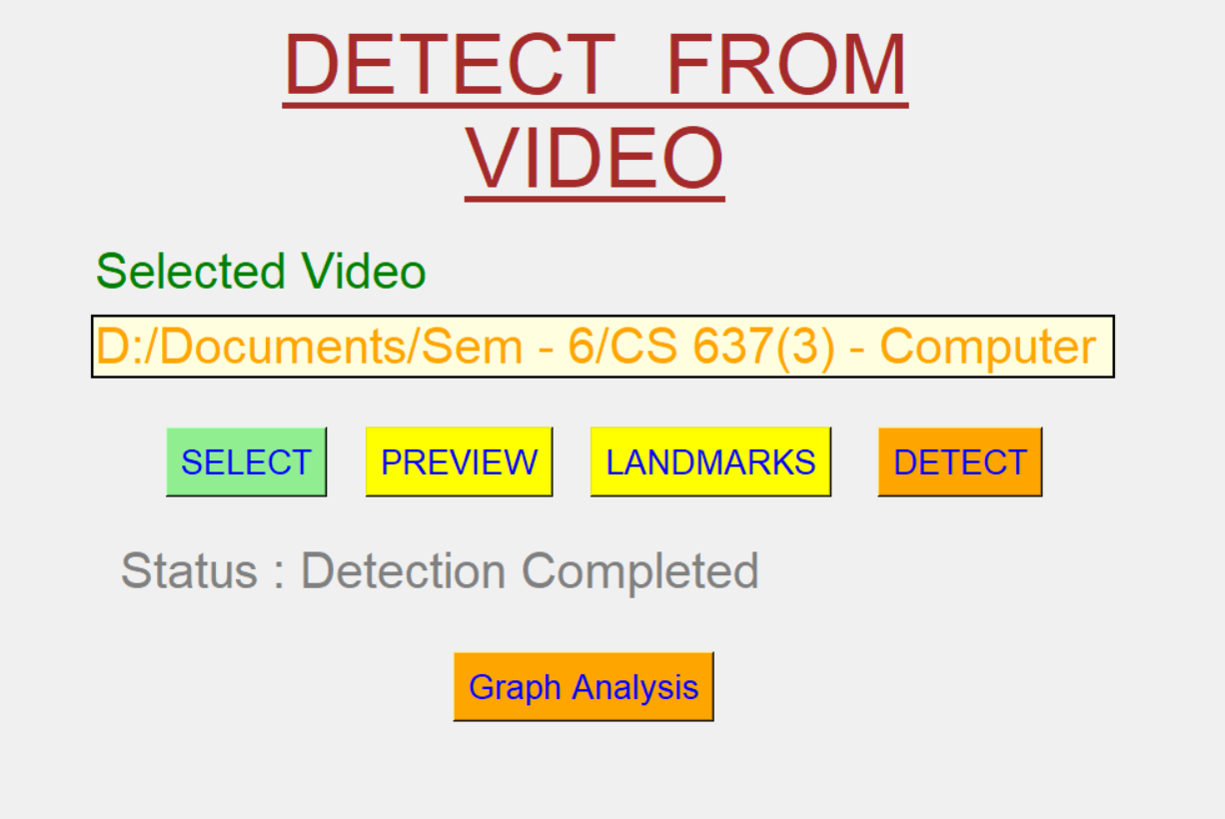

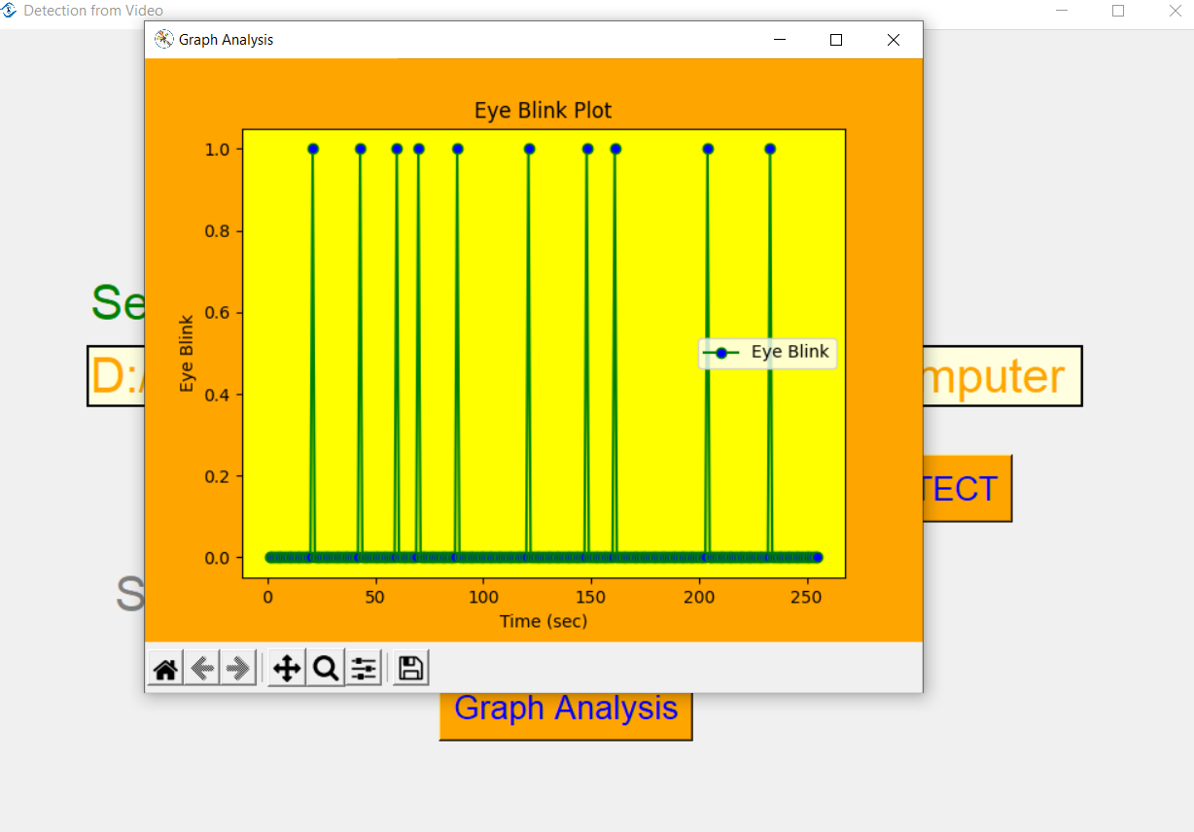

Like this we saw the step wise implementation of model works on video same way it works also on through camera. Where it asks to open the camera, and will be able to see our face’s landmark and also detect the eye position at each interval of time , keeping the count of eye blinking.

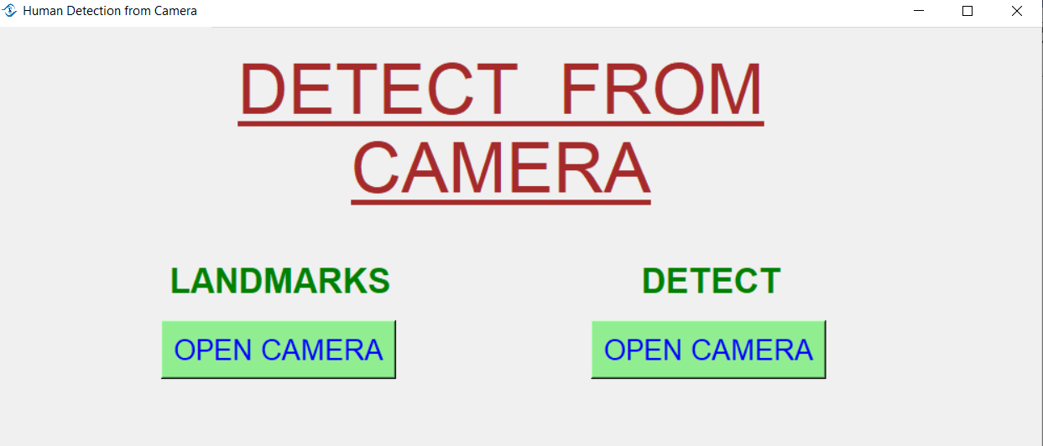

* **CONCLUSION & COMMENT**

As a conclusion, user will be able to detect the position of both left and the right eye. And also get the count of eye blink at each frame per second. And at last user can also analyze more via graph between eye blink and time.

As a result, on further implementation of this model on large scale using more better algorithm will definitely be useful in some or the other ways.

**X—X—X—X—X—X—X—X—X**